Codex Sandbox – Quick Start Guide
- Enabling Virtualization
  - Virtualization is a CPU feature on all modern CPUs. Some computers have this enabled by default, and some have it disabled by default. Opening the task manager, under Performance > CPU will show you at the bottom if Virtualization is enabled. If it is enabled, you are done with this step.
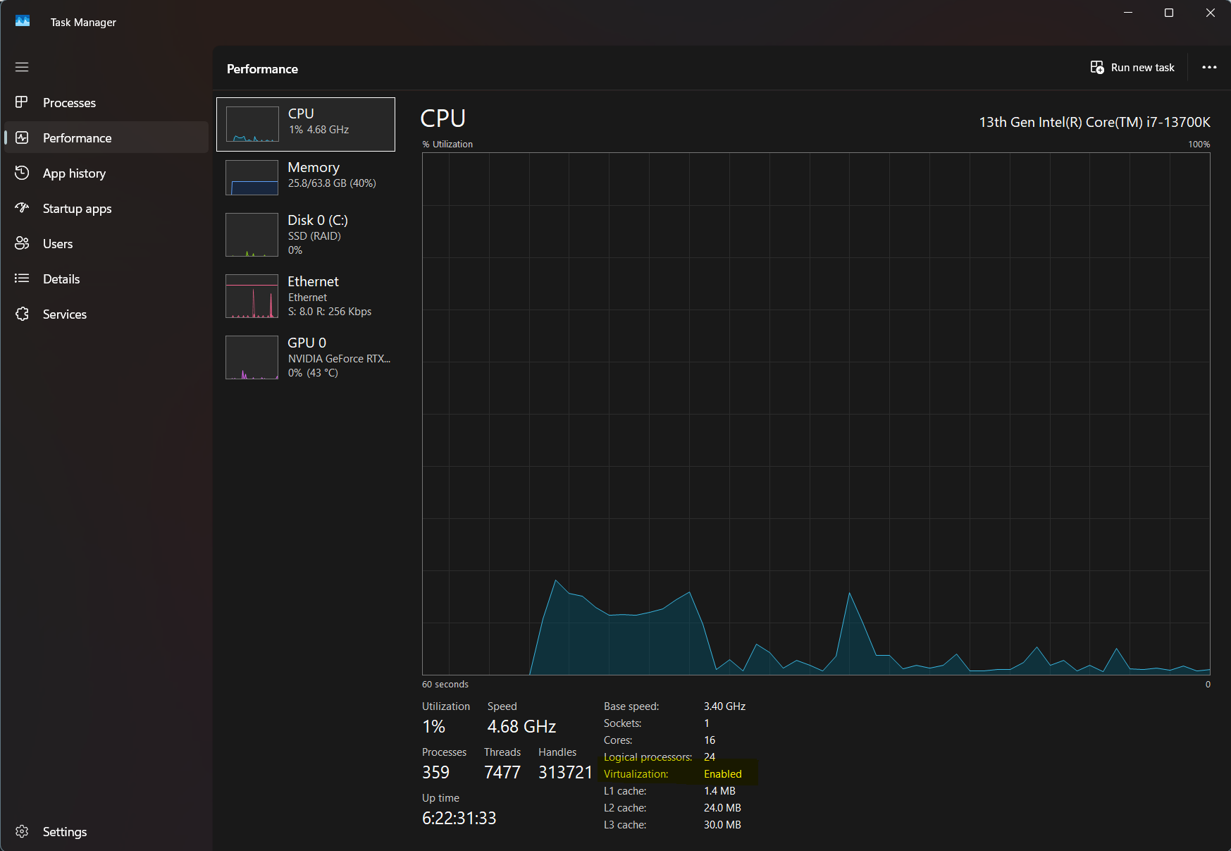
  - If virtualization is not already enabled, it needs to be enabled in the BIOS of the computer. On modern computer setups (UEFI), the process to get into the BIOS can be as simple as pressing <del> or <F2> during startup, or if that is unavailable, go to the Windows Settings > System > Recovery > Advanced Startup > Restart Now which will launch the computer in recovery mode. Inside recovery mode, Troubleshooting > UEFI Firmware Settings > Restart. This will restart the computer and open the BIOS configuration. I recommend not changing any other settings in this configuration except the Virtualization setting – virtualization can have many names. On Intel computers, it is called “Intel VT-x” or “VT-x”, sometimes just “Virtualization” and you will see it disabled and can enable it. On AMD computers, it will be called “AMD-V” or “SVM”. Simply enable it, and save your settings and restart (usually <F10> does this). This will now allow your computer to run virtual machines.
At this point, extract the zip file of the sandbox files into a directory with a name you prefer. I often call mine “codex-sandbox” or I might name it specific to the tasks I want to use, like “website-codex-sandbox”.
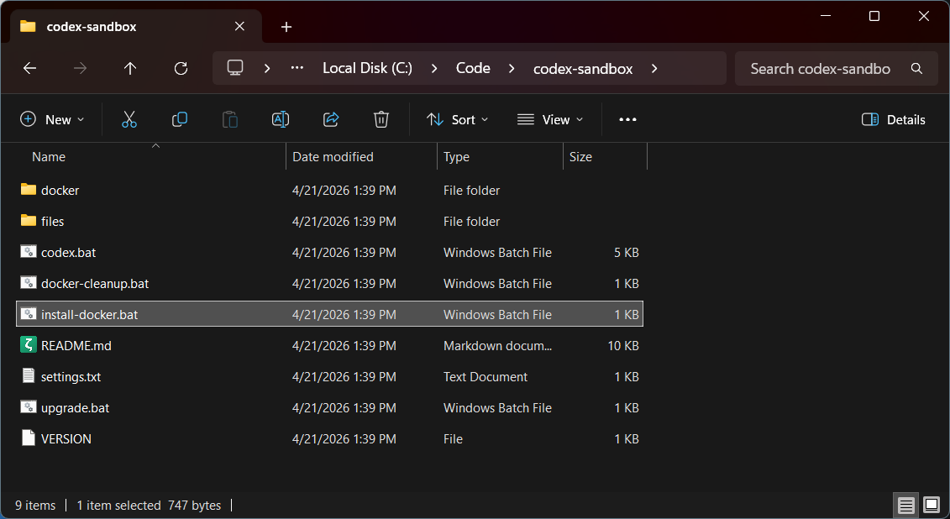
- Docker Desktop
  - To create the sandbox, you will need to install Docker Desktop. You can download it yourself from the website, or run the install-docker.bat script (by double clicking it, or right clicking it and opening it). Docker Desktop requires WSL (Windows Subsystem for Linux is a Microsoft provided Windows component) as well as an updated patch for it. It may require one or two computer restarts before Docker Desktop is able to open successfully, it will likely be a two-step installation process if you have not previously installed WSL.
- Launch the container and login
  - Running the codex.bat script (right click and open, or double click) will run the script to start the codex container/sandbox. The container will take the name of the folder it is in, so you can run multiple sandboxes. It will take some time to download all of the Linux packages and configure them on the first time. Depending on computer speed may take 5 to 60 minutes.
  - Codex will prompt you to login on the first run (or if it has been logged out with /logout). Be sure to use the second option for login, copy and paste (or ctrl + click) the URL provided, you will be asked to login to your OpenAI/Codex account on the website – when successfully logged in it will prompt you for the 8-digit code provided in the Codex sandbox window. If you enter this code into the browser the login will be complete and the sandbox will be available to use
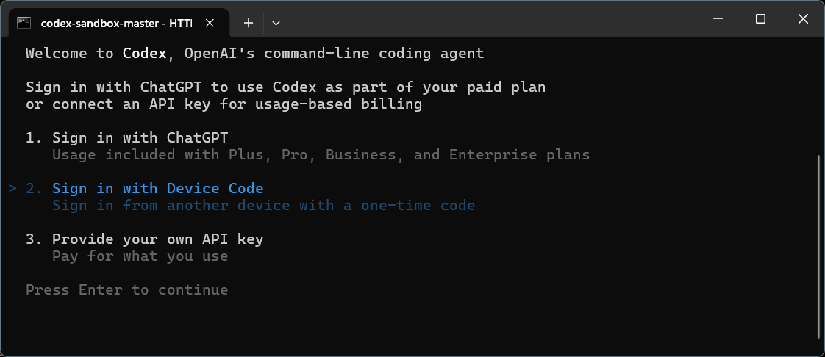
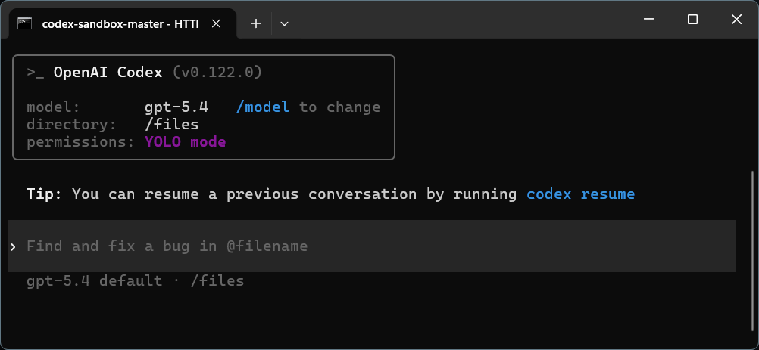
- Files
  - The sandbox is configured to bypass permissions and proceed with operations, but it cannot access any files outside of the “Files” directory in your sandbox folder. Any files you need to work with you should copy into the Files directory.
  - The Codex sandbox will be able to install any Linux software it may need, any python libraries or other software it deems necessary to work. It has access to the network and can download/access any websites that your browser is able to. It also has a few plugins that improve planning, brainstorming, and debugging, as well as a headless browser it is able to use to aid development or crawling websites.

